

 Store with IPFS – Decentralized File Upload  
  
**Objective/Aim:**  
  
 To study the working of the InterPlanetary File System (IPFS) and practically explore how files can be uploaded,

stored, and accessed in a decentralized manner without depending on centralized servers.

**Apparatus/Software Used:**

* Personal Computer or Laptop
* Internet Connection
* IPFS tool (Pinata / web3.storage / IPFS Desktop or CLI)
* Web browser

**Theory/Concept:**

**InterPlanetary File System (IPFS):**

IPFS is a distributed network protocol designed to make file storage and sharing faster, safe and independent of centralized systems. Instead of using a location-based system (like HTTP URLs), it works with **content addressing** using a unique identifier called **CID**.

**Key Points:**

* **Content Identifier (CID):** A cryptographic hash generated from file content, ensuring integrity and uniqueness.
* **Decentralization:** Data is distributed across multiple nodes instead of being stored in one central server.
* **Immutability:** Once uploaded, a file’s CID does not change unless its content is modified.
* **Pinning:** To prevent automatic deletion, files must be pinned through pinning services.
* **Data Retrieval:** Files can be fetched using CIDs from any IPFS gateway

**Working Principle:**

1. A file is divided into small blocks.
2. Each block is hashed to generate CIDs.
3. These blocks are distributed across nodes in the IPFS network.
4. Anyone with the CID can retrieve the file from nearby nodes or through a public IPFS gateway.



**Procedure:**

**Step 1:** Go to <https://pinata.cloud> or install IPFS Desktop.

**Step 2:** Register or log in to the platform..

**Step 3:** Choose a file (e.g., .jpg, .pdf, .txt) and upload it.

**Step 4:** After successful upload, note down the **CID** generated.

**Step 5:** Open a web browser and access the file using:  
 [https://gateway.pinata.cloud/ipfs/<CID](https://gateway.pinata.cloud/ipfs/%3cCID)>

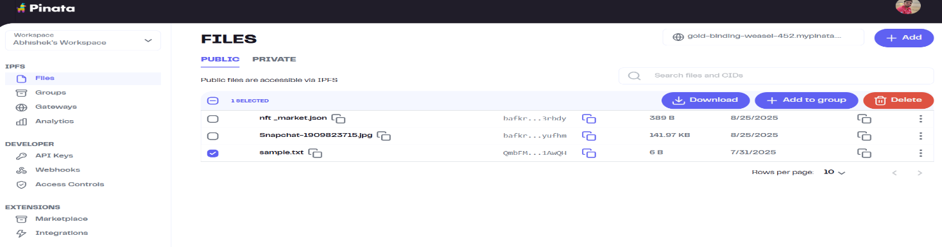**Step6:**Try retrieving the file from different devices to confirm accessibility.

**Observation Table:**

|  |  |  |  |
| --- | --- | --- | --- |
|  |  |  |  |
|  |  |  |  |
|  |  |  |  |
|  |  |  |  |
|  |  |  |  |
|  |  |  |  |
|  |  |  |  |





| **Feature** | **IPFS Characteristics** |
| --- | --- |
| **Definition** | A distributed peer-to-peer protocol for storing and sharing files |
| **Control** | Operated collectively by nodes across the network |
| **Data Integrity** | Ensured using cryptographic hashes (CIDs) |
| **Examples** | IPFS, Filecoin, web3.storage, Pinata |
| **Privacy** | Users have more control over data, no third-party monetization |
| **Accessibility** | Files available via CIDs and multiple IPFS gateways |
| **Security** | Tamper-proof, resistant to unauthorized changes |
| **Censorship** | Difficult to censor because files are spread across nodes |
| **Scalability** | May face performance issues with very large datasets |